Security audit report (SQL Injection, CSRF tests)

1.sql injection tests
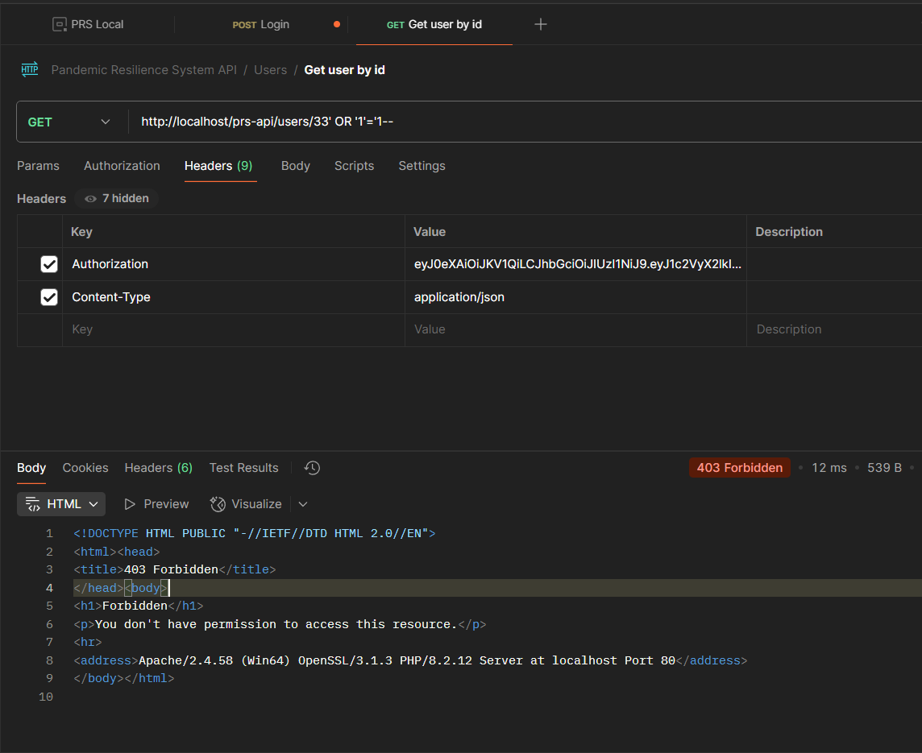
Test 1: GET User by ID
- Endpoint: GET /users/{id}
- Payload: http://localhost/prs-api/users/33' OR '1'='1--
- Response: 403 Forbidden
- Status: ✅ SECURE
- Notes: API correctly blocks malicious SQL injection attempts

ΓΙΑ ΤΟ login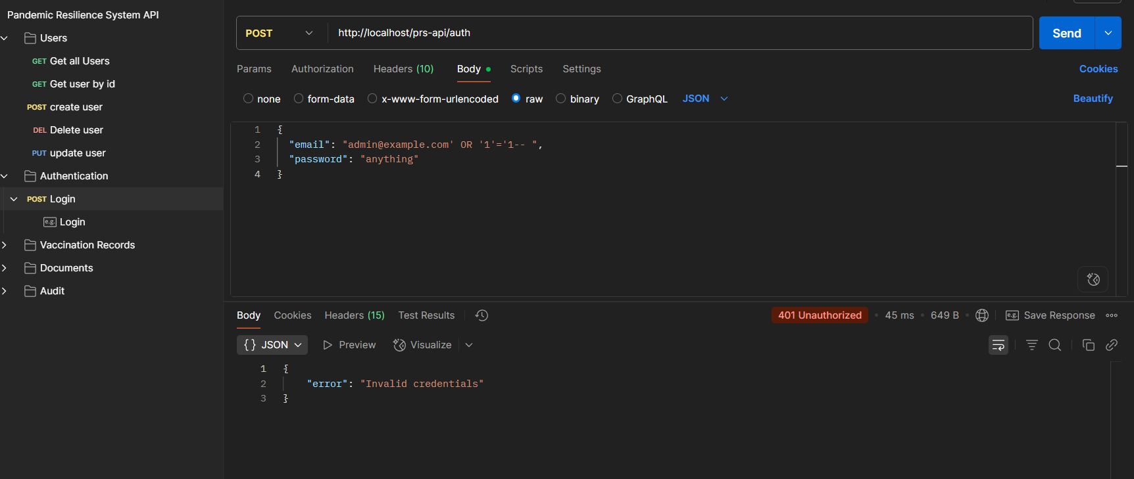
Test 3: Create User (POST) – with valid token
- Endpoint: POST /users
- Payload: SQL injection to name, email, password fields
- Response: "Invalid email format"
- Status: ✅ SECURE
- Notes: API validation successfully blocks malicious SQL payloads
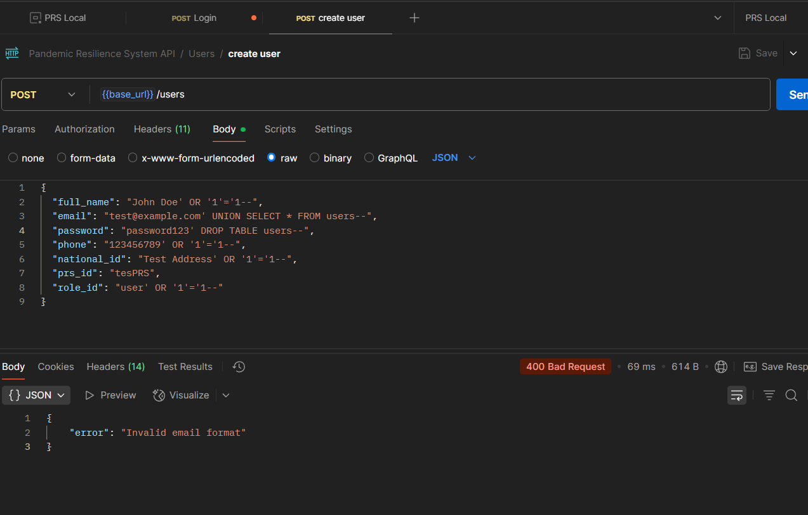
Test 4: GeT Record by Id(GET) – with valid token
- Endpoint: GET / vaccination
- Payload: SQL injection
- Response: "Forbidden"
- Status: ✅ SECURE
- Notes: API validation successfully blocks malicious SQL payloads
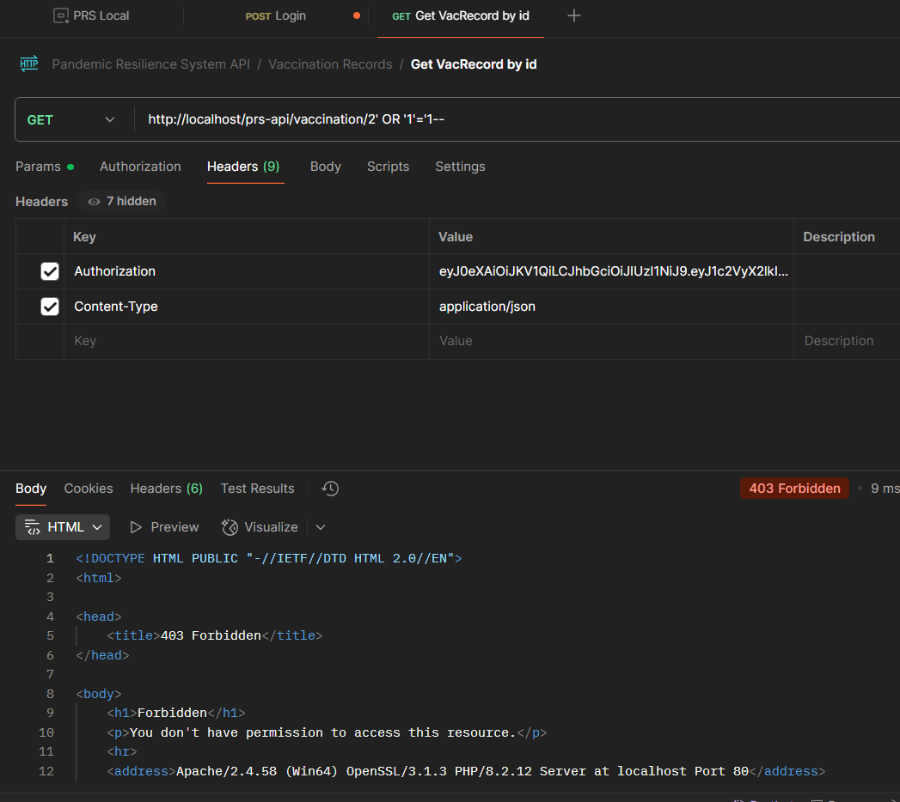
Test5 the same results with the test 4
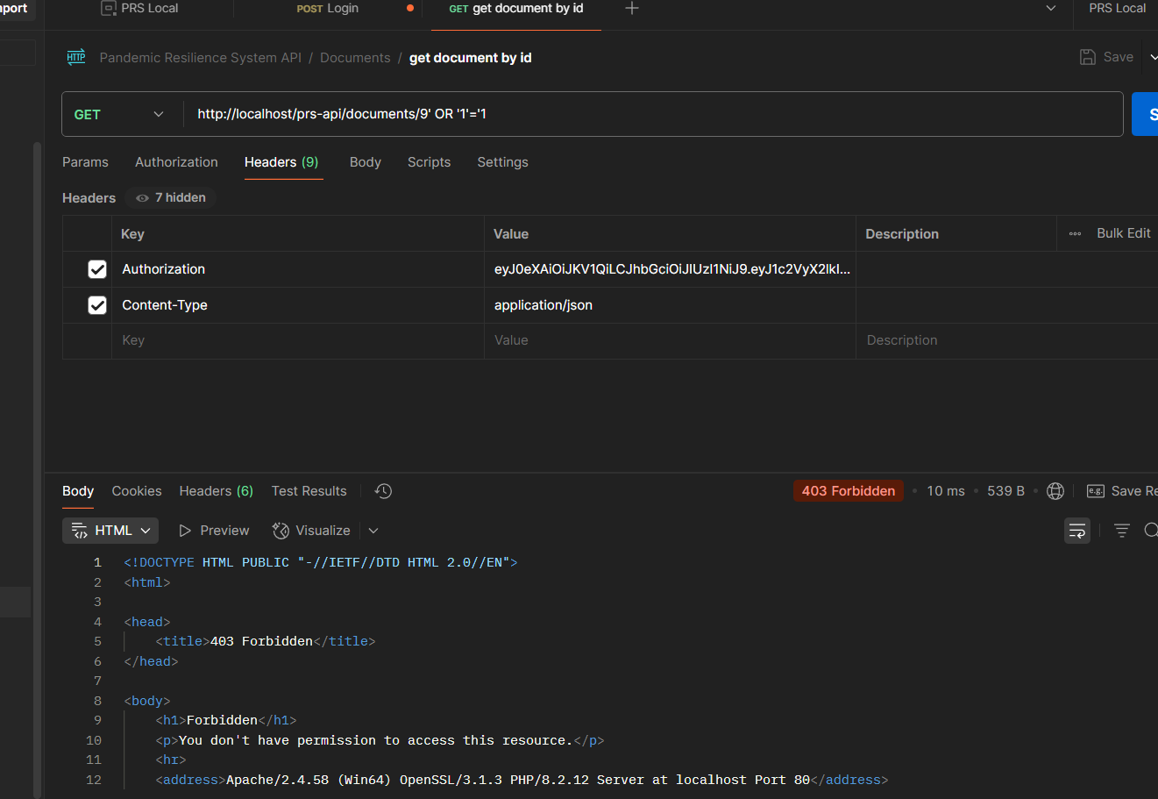

CSRF TEST RUN THE HTML csrf_test.html without token
